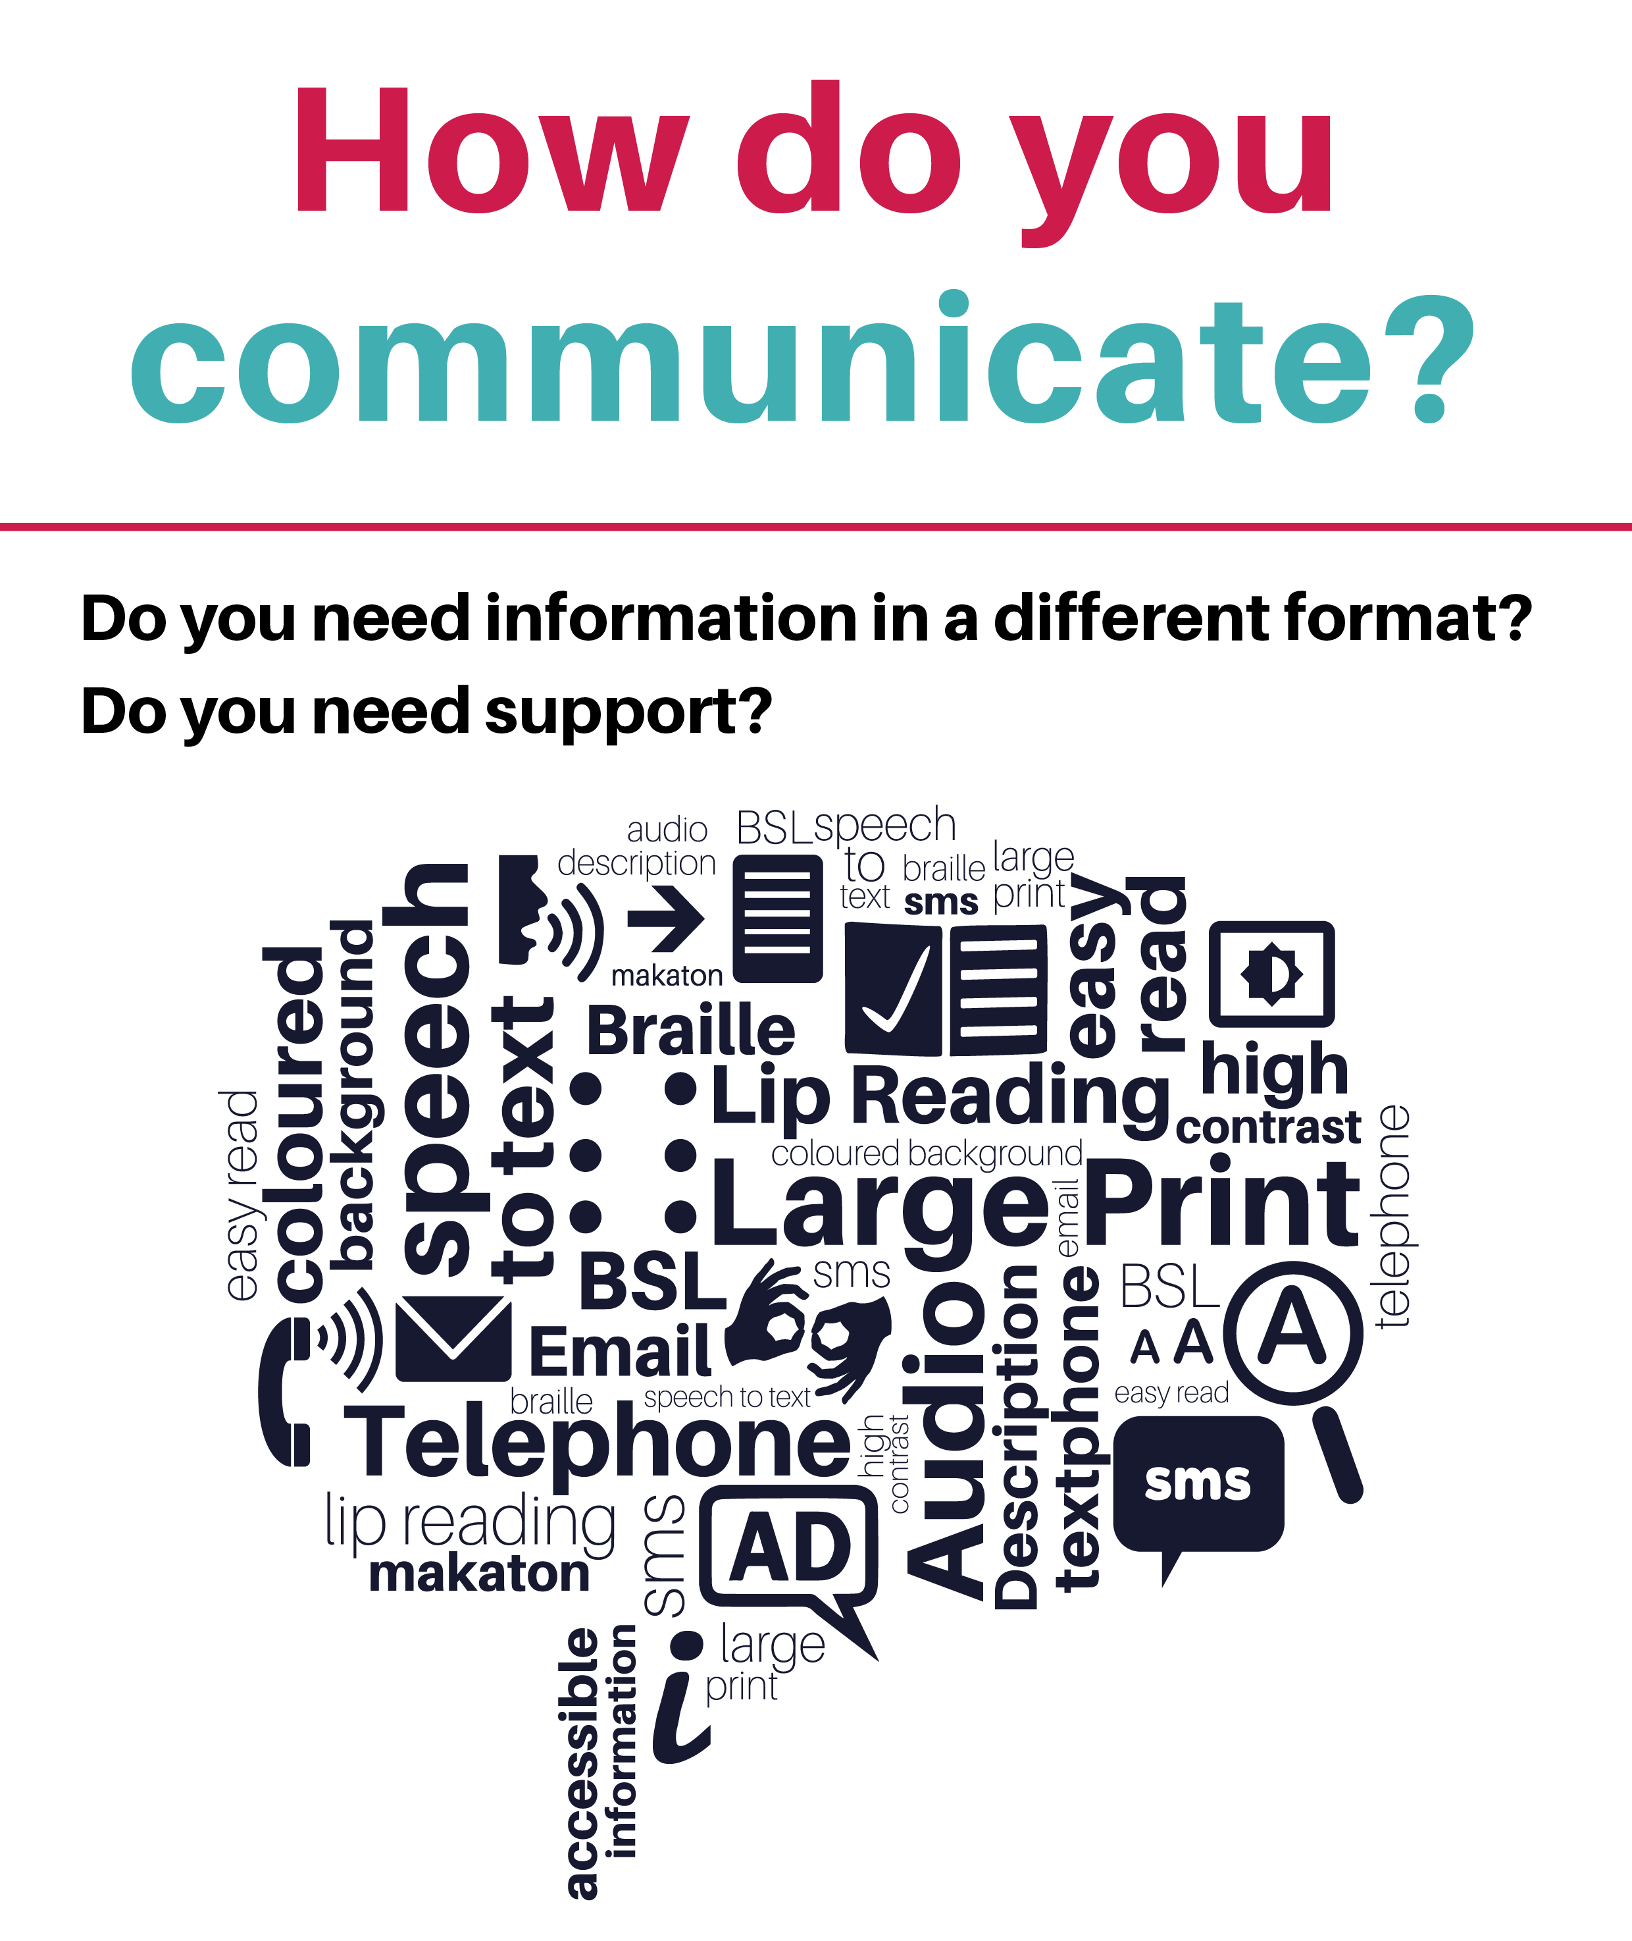
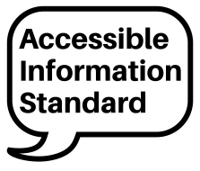
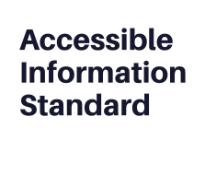
Tell us today
Telephone: 0191 456 0463 / 0191 2832020
Email: STYNCCG.DrHaquesSurgery.nhs.uk
Project funded by NHS England
Project funded by NHS England
Project funded by NHS England
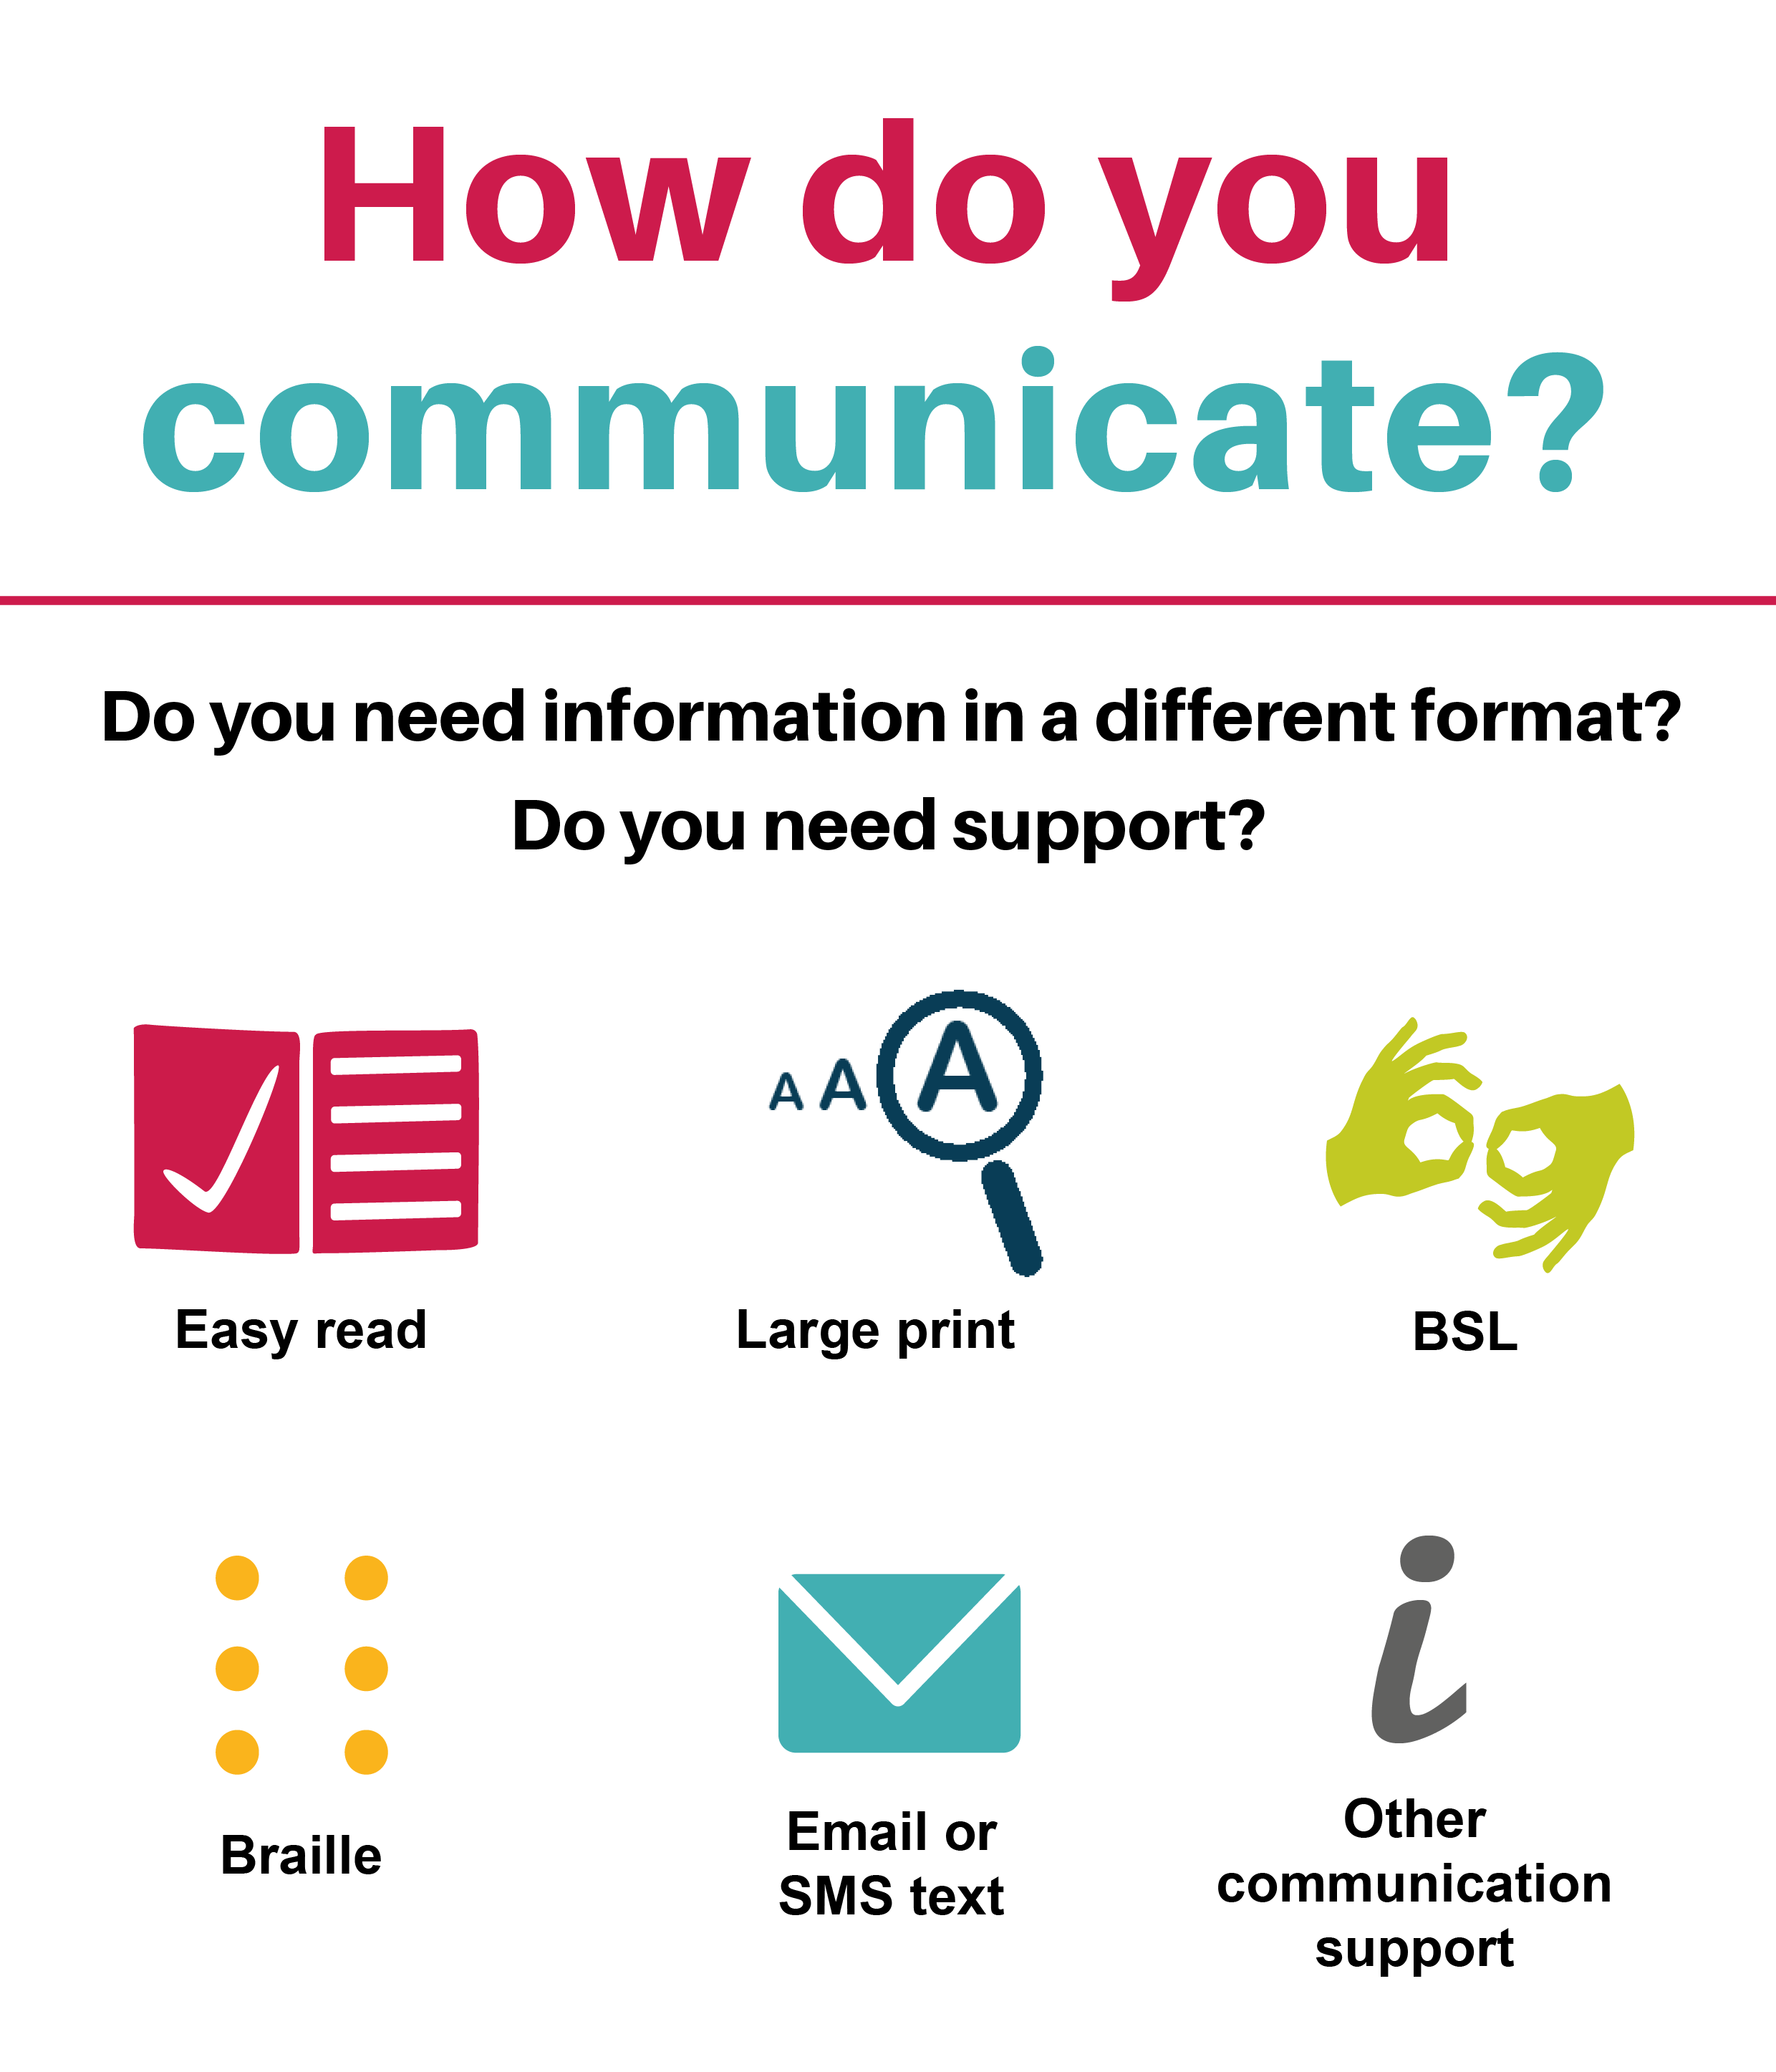
Tell us today
Telephone: 0191 4560463 / 0191 2832020
Email: STYNCCG.DrHaquesSurgery.nhs.uk
Project funded by NHS England
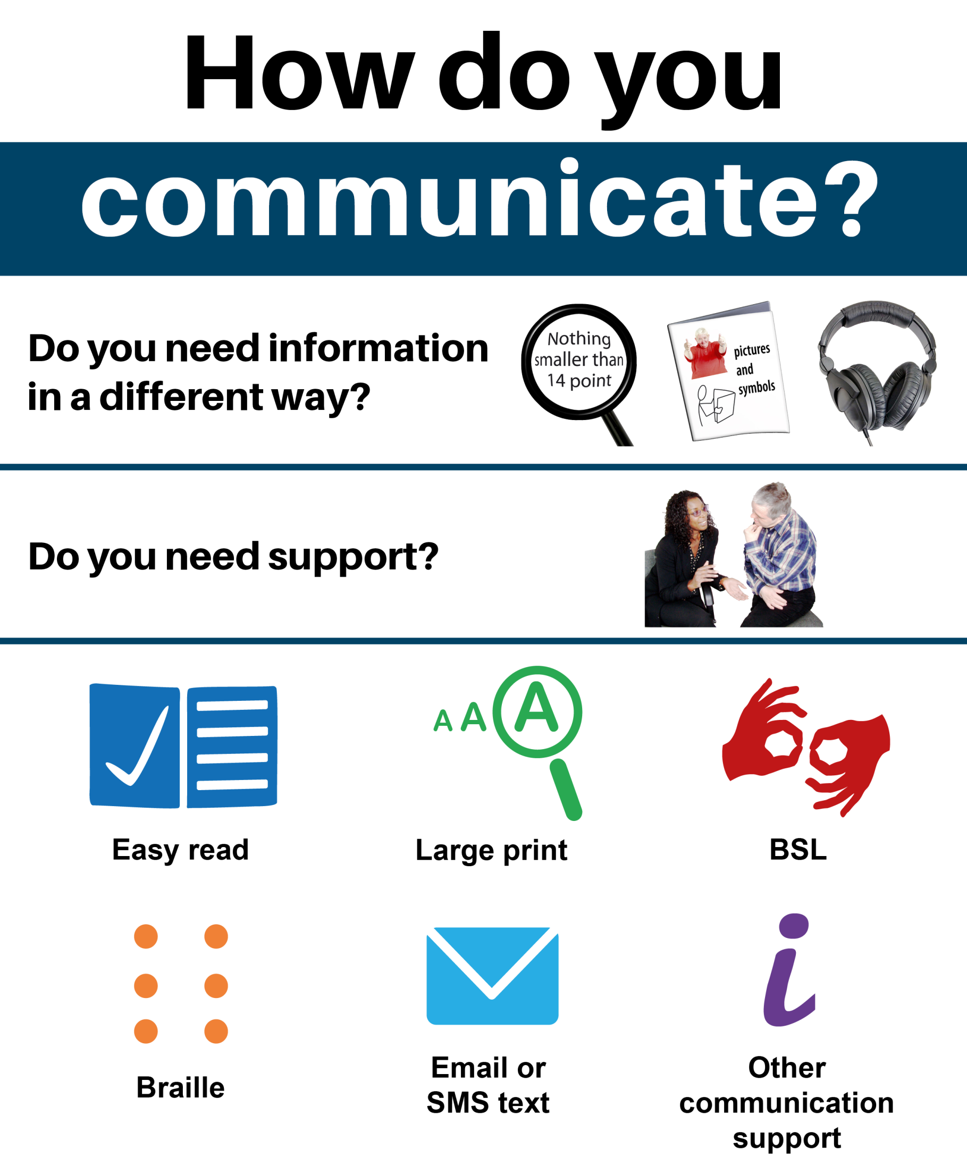
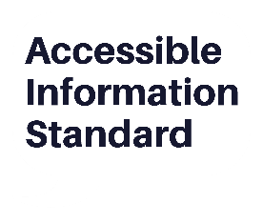
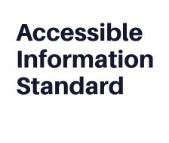
Tell us today
Telephone: Insert telephone number here
Email: Insert email address here
Insert
Logo
Here
Tell us today
Telephone: 0191 4560463 / 0191 2832020
Email: STYNCCG.DrHaquesSurgery.nhs.uk
Project funded by NHS England

